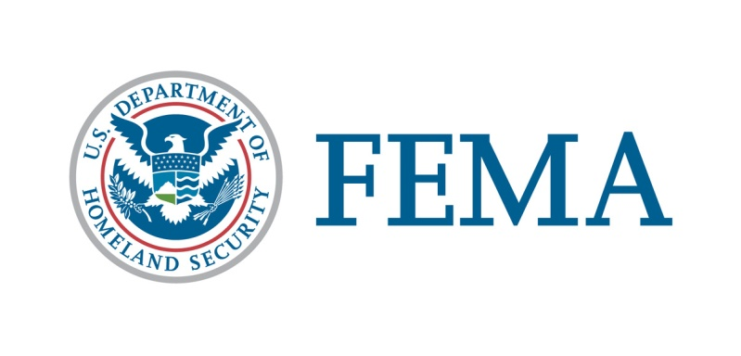

##### Congressional Affairs Division

202-646-4500

**State of Maryland**

**Federal Disaster Declaration Fact Sheet**

**June 25, 2018**

Today, June 25, 2018, President Donald J. Trump granted a Major Disaster Declaration for the State of Maryland triggering the release of Federal funds to help communities recover from the Severe Storms and Flooding that occurred May 15-19, 2018.  Details of the disaster declaration and assistance programs are as follows:

Declaration Number:                         FEMA-4374-DR

Incident:                                            Severe Storms and Flooding

Incident Period:                                May 15-19, 2018

Federal Coordinating Officer:           Emily Breslin

                                                           National FCO Program

Public Assistance (PA):                    (Assistance for emergency work and the repair or replacement of disaster-damaged facilities):

PA-Designated Counties:                  Frederick and Washington.

Hazard Mitigation (HM):                  (Assistance for actions taken to prevent or reduce long term risk to life and property from natural hazards):

HM-Designated Areas:                     All areas in the State of Maryland are eligible for assistance under the Hazard Mitigation Grant Program.

OTHER:                                            Additional designations may be made at a later date if requested by the State and warranted by the results of further damage assessments.

                                                                                                      ###